26 .Aim :To Design TM using simulator to accept the input string Palindrome bbabb

INPUT:

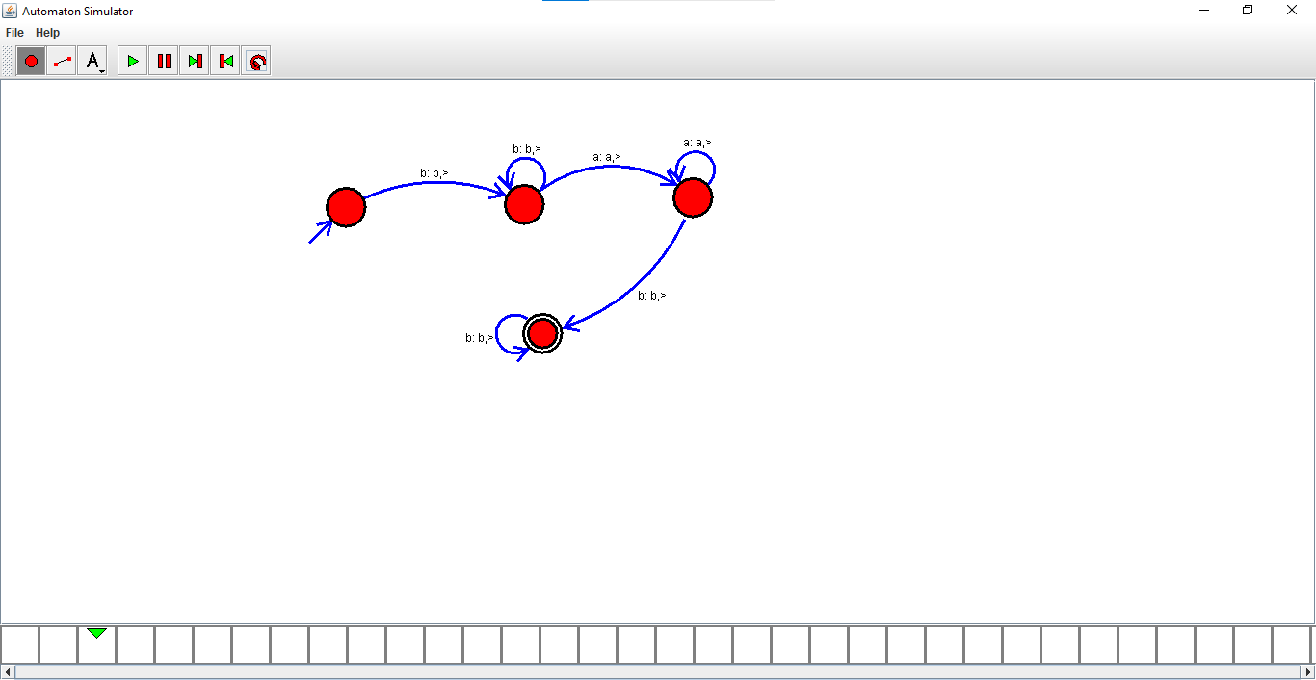

OUTPUT:

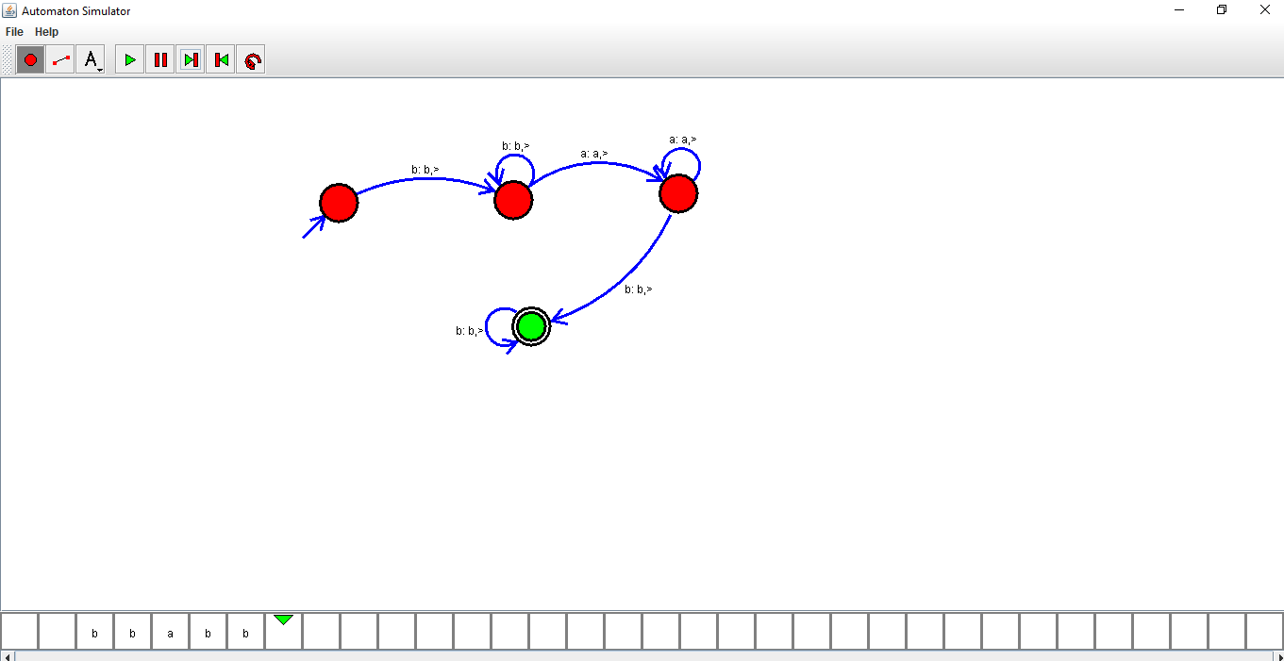

RESULTS:Designed TM using simulator to accept the input string Palindrome bbabb